## COVID VACINESS ANALYSIS

PROBLEM DEFINITION

The problem is to conduct an in-depth analysis of Covid-19 vaccine data, focusing on vaccine efficacy, distribution, and adverse effects. The goal is to provide insights that aid policymakers and health organizations in optimizing vaccine deployment strategies. This project involves data collection, data preprocessing, exploratory data analysis, statistical analysis, and visualization.

ABSTRACT

The COVID 19 pandemic caused due to the Corona virus devastated the world by causing several fatalities around the world. This virus originated in Wuhan, China in 2019 and was later spread throughout the world due to human contact in one way or the other. The disease showed symptoms as basic as mild fever and cold but also caused life threatening symptoms like breathing problems caused by damage to the lungs. As this virus was new to the world and there was no vaccine or cure to it at the initial period there were several deaths around the world.

This Project mainly aims to find out the vaccinations around the world for the prevention of the Covid 19 pandemic and how much has been achieved so far.

The countries around the world were forced to shut themselves to others in order to avoid the further spread of the virus and people were stuck inside their houses and faced many issues with their finances, mental health etc., and felt like animals in a cage. An effort was made to find a cure or vaccine by several health organizations to bring a stop to this pandemic

DATA COLLECTION

**Vaccine Distribution**: Tracking the quantity and location of vaccine doses distributed to healthcare providers and vaccination centers.

**Vaccine Administration**: Recording the number of doses administered, including details like date, location, and recipient demographics.

**Safety Monitoring**: Continuously monitoring and collecting data on adverse events following vaccination (AEFIs) to ensure vaccine safety.

**Efficacy Studies**: Conducting clinical trials and post-marketing surveillance to assess the effectiveness of vaccines in preventing COVID-19.

**Vaccine Coverage**: Determining the percentage of the population vaccinated to gauge progress toward herd immunity.

EXPLORATORY DATA ANALYSIS

**Vaccine Distribution**: Tracking the quantity and location of vaccine doses distributed to healthcare providers and vaccination centers.

**Vaccine Administration**: Recording the number of doses administered, including details like date, location, and recipient demographics.

**Safety Monitoring**: Continuously monitoring and collecting data on adverse events following vaccination (AEFIs) to ensure vaccine safety.

**Efficacy Studies**: Conducting clinical trials and post-marketing surveillance to assess the effectiveness of vaccines in preventing COVID-19.

**Vaccine Coverage**: Determining the percentage of the population vaccinated to gauge progress toward herd immunity.

**Variants Monitoring:** Collecting data on the prevalence and impact of COVID-19 variants on vaccine efficacy.

**Patient Records**: Ensuring proper record-keeping of vaccine recipients' information for follow-up doses and adverse event management.

Data collection is typically performed by healthcare agencies, vaccine manufacturers, research institutions, and government health departments, and it plays a crucial role in managing the COVID-19 pandemic.

STATSTICAL ANALAYISIS

**Data Collection**: Gather data on vaccine administration, infection rates, and outcomes. This data can come from clinical trials, real-world studies, and healthcare records.

**Define Metrics**: Identify what you want to measure, such as vaccine efficacy (preventing infection) or vaccine effectiveness (real-world impact on reducing illness and transmission).

**Study Design**: Choose the type of study - randomized controlled trials, observational studies, or ecological studies. Ensure the study design accounts for confounding variables.

**Comparative Analysis**: Compare infection rates, hospitalization rates, and mortality among vaccinated and unvaccinated groups.

**Adjust for Confounders**: Account for variables like age, comorbidities, and geographic location that can influence outcomes.

**Time Analysis:** Evaluate vaccine effectiveness over time, considering variants and changes in vaccine distribution.

VISUALIZATION

In the analysis part first | have analyzed the top 10 fully vaccinated countries by using area chart and have used the filter option to find the top countries and the result obtained as below,

From the below image we can able to come to know that India is the top country in terms full vaccination with 116 billon , followed by united states of America and china with 67 billion and 35 billion respectively.

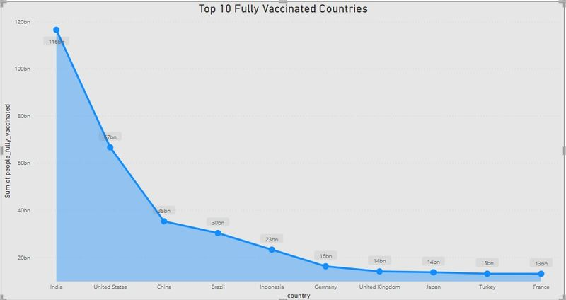

In the second analysis we have analyzed the top 5 vaccinated countries with the help of pie chart and used filter option to find the top countries and with that we came to know that India is the top country with more number of vaccinated peoples followed by United States of America and Brazil.

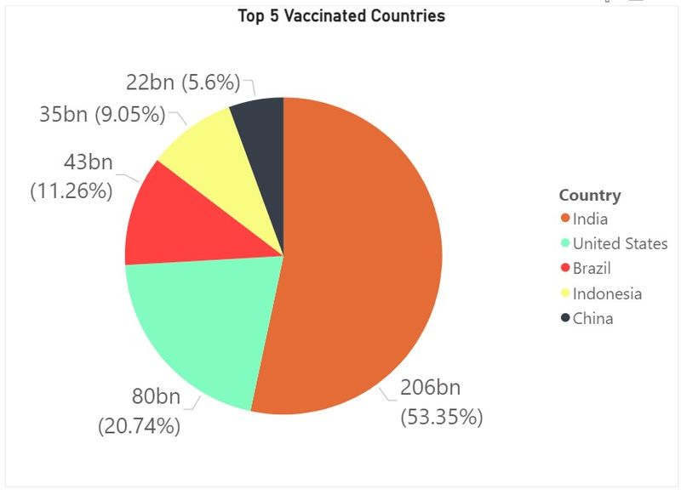

Fully vaccinated people by the year

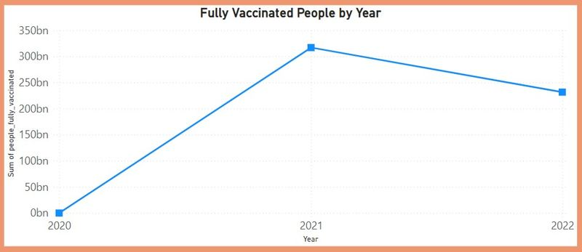

INSIGHTS AND RECOMMENDATIONS

**Insight 1**: Vaccine Coverage Disparities

**Insight**: There are disparities in vaccination rates among different demographic groups, with some populations being under-vaccinated.

**Recommendation**: Implement targeted outreach and vaccination campaigns to address these disparities. This may include setting up vaccination sites in underserved areas, providing transportation assistance, and culturally sensitive education efforts.

**Insight 2:** Vaccine Hesitancy

**Insight:** Vaccine hesitancy remains a challenge, leading to lower vaccination rates.

**Recommendation**: Develop and disseminate evidence-based educational materials to address vaccine hesitancy concerns. Engage with community leaders, healthcare providers, and influencers to promote vaccine confidence.

**Insight 3**: Vaccine Efficacy

**Insight:** Ongoing monitoring shows variations in vaccine efficacy against new COVID-19 variants.

**Recommendation:** Continue genomic surveillance to track variant prevalence and adapt vaccination strategies as needed, such as booster doses or updated vaccines targeting emerging variants.

**Insight 4**: Adverse Events

**Insight**: Data shows a low rate of severe adverse events following vaccination.

Recommendation: Maintain robust adverse event monitoring systems, and ensure transparent reporting of vaccine safety data to build and maintain public trust.

**Insight 5**: Booster Doses

**Insight**: Evidence suggests that booster doses may be necessary to maintain long-term immunity.

**Recommendation**: Plan and implement booster shot campaigns for eligible populations, prioritizing those at higher risk of severe disease or waning immunity